Some EPIC tips for enjoying Juan-les-Pins

https://www.antibesjuanlespins.com/en/must-see-must-do

Things to do in Juan-les-Pins

Relax on the Beaches: Boulevard d'Aguillon, 06160 Juan-les-Pins
Why go: Juan-les-Pins is famous for its beautiful sandy beaches, making it a perfect place to relax and soak up the sun. The main beach, Plage de la Gravette, is long and sandy. There are also several private beaches with sun loungers, umbrellas, and water sports rentals available.
Explore the Pine Grove (Parc de la Pinède) : Avenue Georges Pompidou, 06160 Juan-les-Pins
Why go: The Parc de la Pinède is a beautiful pine grove located next to the beaches. It's a lovely spot to escape the hustle and bustle of the town center and enjoy a peaceful walk in nature. The park also hosts the annual Jazz à Juan music festival in July and August.
Stroll Along the Promenade du Soleil: Runs along the coast of Juan-les-Pins, 06160 Juan-les-Pins
Why go: The Promenade du Soleil is a lively pedestrian promenade that stretches along the coastline of Juan-les-Pins. It's a great place to people-watch, enjoy the sea views, and grab a bite to eat at one of the many cafes and restaurants.

Experience the Nightlife: Various locations throughout Juan-les-Pins
Why go: Juan-les-Pins is known for its vibrant nightlife scene, with a wide variety of bars, clubs, and casinos to choose from..
Visit the Église Notre-Dame-de-la-Pinède: 20 Avenue Georges Pompidou, 06160 Juan-les-Pins
Why go: Église Notre-Dame-de-la-Pinède is a beautiful 19th-century church located in the heart of Juan-les-Pins. It's a peaceful place to escape the crowds and admire the architecture.

If you have 30-minute: Explore the heart of Juan-les-Pins

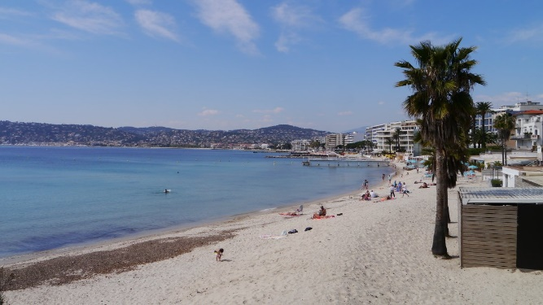
- Start from the Palais des Congres and head south on Boulevard d'Aguillon towards the pine grove.
- Enjoy the scenic walk along the Juan-les-Pins beaches.
- Turn inland on Rue du Cap for a charming stroll past cafes, boutiques, and art galleries.
- Return to the Congress Centre via Rue Guisol.

If you have 1-hour: Walk the Cap d'Antibes Lighthouse & Juan-les-Pins Beaches

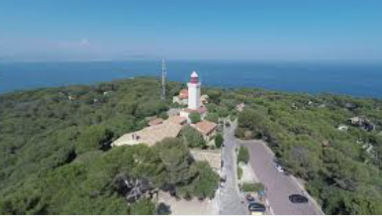
- Follow the route mentioned in walk #1 until you reach the pine grove.
- Take a detour towards the west on Avenue du Cap to reach the Cap d'Antibes Lighthouse (Phare du Cap d'Antibes).
- Enjoy the panoramic views of the coastline.
- Retrace your steps back to the pine grove and continue the walk along the beaches until you reach the Congress Centre.

If you have 2 hours: Walk old Antibes and Juan-les-Pins Beaches

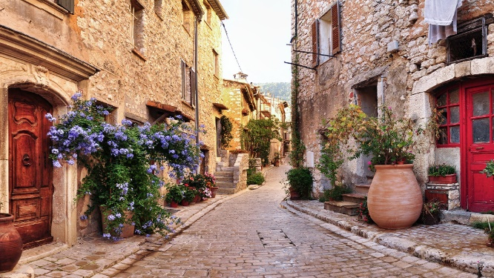
- This extended walk combines the best of both worlds: scenic beaches and historic Antibes.
- Follow the route mentioned in walk #2 until you reach the Cap d'Antibes Lighthouse.
- From the lighthouse, head south on Chemin de la Garoupe for stunning coastal views.
- Continue on this path until you reach the old town of Antibes. Explore the historic center, ramparts, and the Picasso Museum.
- To get back to Juan-les-Pins, you can take a bus or taxi (around 15 minutes) or walk along the coast for another hour (challenging due to uneven terrain).

If you have 4 hours: The Scenic Antibes Loop

This walk offers a fantastic combination of coastal beauty, historical sites, and a charming village. Be sure to wear comfortable shoes and bring water, sunscreen, and a hat for this longer trek.

Route:

- Start: Antibes Juan-les-Pins Congress Centre.
- Head South (1 hour): Follow the route from walk #1 until you reach the pine grove. Enjoy the scenic walk along the Juan-les-Pins beaches.
- Cap d'Antibes Lighthouse (1 hour): Turn west on Avenue du Cap and head towards the Cap d'Antibes Lighthouse. Take in the breathtaking panoramic views of the coastline.
- Garoupe Loop (1.5 hours): From the lighthouse, continue south on Chemin de la Garoupe for stunning coastal cliffs. Follow this path all the way around the Garoupe peninsula, enjoying the beautiful scenery.
- Antibes Old Town (1 hour): After completing the Garoupe loop, you'll arrive in the heart of Antibes Old Town. Explore the charming streets, ramparts, and the Picasso Museum.
- Fort Carré (30 minutes): Head east towards the harbor and visit the impressive Fort Carré, a 16th-century star-shaped fort.
- Port Vauban (30 minutes): Continue along the harbor to Port Vauban, one of the largest marinas in Europe. Admire the luxurious yachts and lively atmosphere.
- Juan-les-Pins Beaches (30 minutes): Finally, walk back to the Congress Centre along the Juan-les-Pins beaches, taking in the final stretch of the scenic coastline.
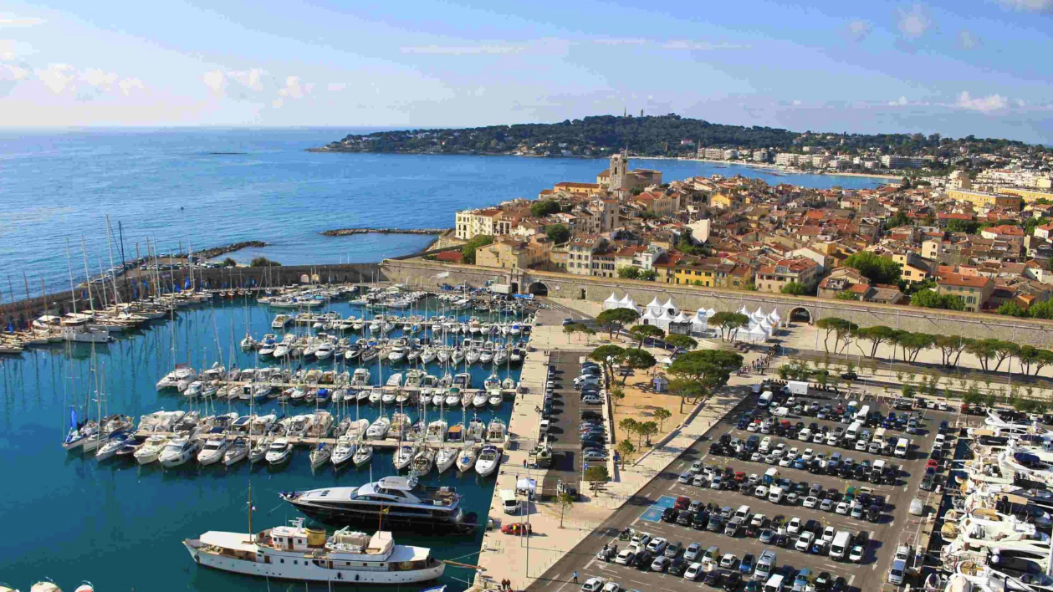

WE HOPE YOU ENJOY JUAN LES PINS & THE EPIC SUMMIT

Emergency contact:

Carlos Lee, Director General
EPIC – European Photonics Industry Consortium
WhatsApp/Mobile : + 32 473300433
Carlos.Lee@epic-photonics.com

