EPIC LIFETIME ACHIEVEMENT AWARD 2024: VIACHESLAV (SLAVA) ARTYUSHENKO, CEO, ART PHOTONICS
Acknowledging exceptional leadership in the field of special optical fibers and spectroscopy fiber probes

Basil Garabet, president of EPIC, delivers the EPIC Lifetime Achievement to Viacheslav (Slava) Artyushenko, CEO of art photonics, for his leadership in the Optical Fibers Industry.

Juan-Les-Pins, France - 18 April 2024 - EPIC (European Photonics Industry Consortium) has announced Slava Artyushenko as the recipient of the EPIC Lifetime Achievement Award for his outstanding contributions and leadership in the Optical Fibers Industry. Viacheslav (Slava) Artyushenko, the CEO of art photonics GmbH, has led the company to become a major player in the global market for special optical fibers' products & spectroscopy fiber probes.
Born in 1954, Slava Artyushenko graduated from Moscow Physical-Technical Institute and got his PhD in physics of solid state in 1981. In 1998 he founded art photonics GmbH in Berlin, Germany to use his Polycrystalline IR-fibers technology to develop fiber probes for spectroscopy, medical diagnosis, and control of industrial processes as well as high-power laser cables for medical, industrial and scientific lasers. The company has become one of the worldwide leading manufacturers of fiber cables, bundles, and spectroscopy probes for industrial, medical, and scientific applications, offering a very broad spectral range from 0.3 to 16µm. In December 2023, art photonics was acquired by the Nynomic Group.
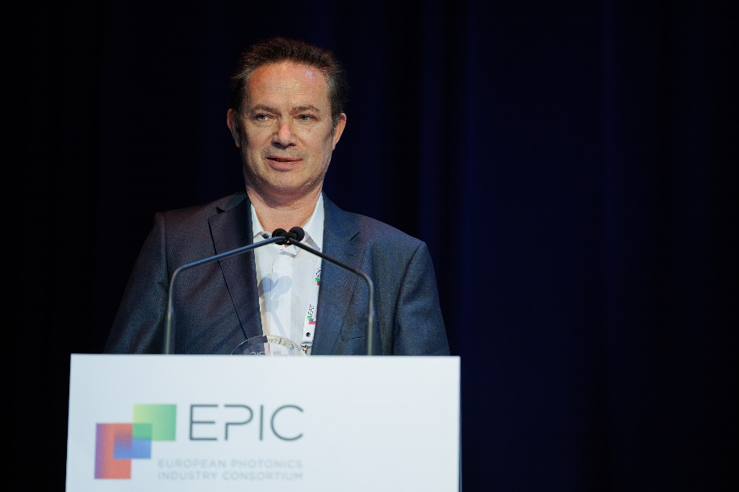
Slava Artyushenko holds numerous papers and patents for fiber optic technologies and applications in a broad spectral range from UV to mid IR. This includes laser medicine, process-spectroscopy, and optic sensing and diagnostics, among others.
Commenting on the award, Slava Artyushenko said, "I am honored to receive this recognition from EPIC. For more than 25 years, art photonics has been setting new standards in the development of special fiber for optical measurement technology. The next step for us was to be acquired by a larger group like Nynomic, and this award is a testament to the hard work and dedication of our team.”
Carlos Lee, Director General of EPIC congratulates him saying “Slava Artyushenko stands out by his kindness and generosity and is one of the most passionate people I know. He continuously extends his support to networks and associations. And he is very smart in identifying new projects and collaboration opportunities”.

About EPIC
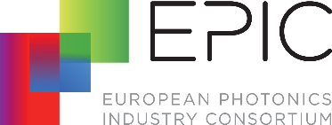
EPIC is the world-leading industry association that promotes the sustainable development of organizations working in the field of photonics. Its members encompass the entire value chain from LED lighting, photovoltaic solar energy, photonic integrated circuits, optical components, lasers, sensors, imaging, displays, projectors, optic fiber, and other photonic-related technologies. EPIC fosters a vibrant photonics ecosystem by maintaining a strong network and acting as a catalyst and facilitator for technological and commercial advancement. EPIC currently represents more than 800 companies across 33 countries. www.epic-assoc.com
Press Contact
Elisenda Lara
elisenda.lara@epic-assoc.com
Mobile: + 34 633 37 62 74

