EPIC CEO AWARD 2024: AXEL KUPISIEWICZ, Founder and CEO of LASEA
Recognizing sustainable growth and leadership in the manufacturing of industrial laser machines

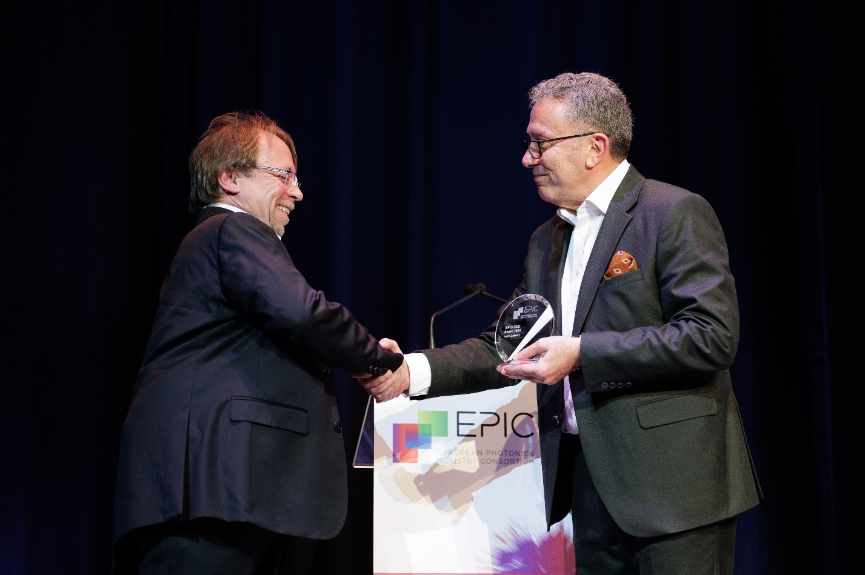
Basil Garabet, President of EPIC presents the EPIC CEO Award 2024 to Axel Kupisiewicz, Founder and CEO of LASEA.

Juan-Les-Pins, France - 18 April 2024 – EPIC (European Photonics Industry Consortium) is delighted to announce that the recipient of the EPIC CEO Award 2024 is Axel Kupisiewicz, Founder and CEO of LASEA. The award recognizes Kupisiewicz’s outstanding leadership and contributions to the photonics industry.
Axel Kupisiewicz holds a master’s degree in applied sciences from ULiège - Belgium and a master's degree in economics and management from HEC - Belgium. After a brief stint in the space sector, he founded LASEA in 1999 at the age of only 25. Pioneering femtosecond lasers since 2003, LASEA specializes in manufacturing micro-machining machines that enable precision cutting, marking, engraving, and drilling. Its main sectors include medical, watchmaking and electronics, with prestigious clients worldwide, including two GAFAMs.
Within two decades, LASEA expanded globally, establishing subsidiaries in France, the US, and Switzerland, securing its position as a leader in ultra-short pulse laser micro-machining. With an annual growth rate of 30% for 12 years, it boasts over 120 patents, employs 190 people, has 3,000 machines installed across 5 continents, and enjoys a consolidated income exceeding 41 million euros.
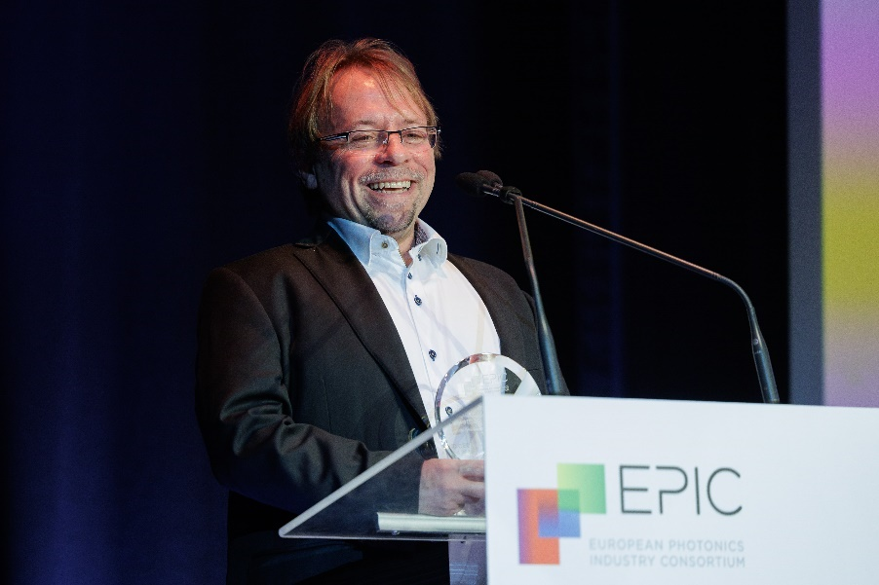
“I am very honored to receive the EPIC CEO Award," said Axel Kupisiewicz. "This award is a recognition of the hard work and dedication of the entire team at LASEA. It also affirms that choosing femtosecond laser technology for micromachining was a wise decision. Additionally, it underscores the importance of always pushing technological boundaries away, alongside our strong market strategy.”

Carlos Lee, Director General of EPIC, commented, "Axel Kupisiewicz exemplifies the values of this award through his persistence, technological leadership, business acumen, … all this to ensure the success of his company and the contribution to the competitiveness of the European photonics industry."

About EPIC
EPIC is the world-leading industry association that promotes the sustainable development of organizations working in the field of photonics. Its members encompass the entire value chain from LED lighting, photovoltaic solar energy, photonic integrated circuits, optical components, lasers, sensors, imaging, displays, projectors, optic fiber, and other photonic-related technologies. EPIC fosters a vibrant photonics ecosystem by maintaining a strong network and acting as a catalyst and facilitator for technological and commercial advancement. EPIC currently represents more than 800 companies across 33 countries. www.epic-assoc.com
Press Contact
Elisenda Lara
Marketing Manager
Mobile: + 34 633 37 62 74
elisenda.lara@epic-assoc.com

