EPIC Welcomes Björn Dymke, Managing Director of TRUMPF Laser to its Board of Directors
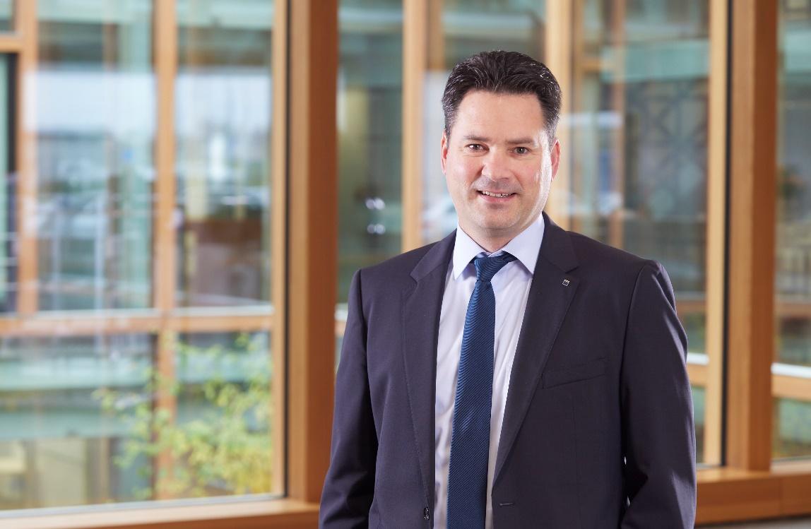
Nice, France – 17 April 2024 - During the Annual General Meeting 2024 celebrated in Nice, France, the European Photonics Industry Consortium has confirmed Björn Dymke, Managing Director of TRUMPF Laser, to join its Board of Directors. With extensive experience in photonics technology and a deep understanding of the industry, Dymke will bring valuable insight and perspective to EPIC's mission of promoting and advancing the photonics industry in Europe.

We are delighted to welcome Björn Dymke to EPIC's Board of Directors," said Carlos Lee, Director General of EPIC. "He is a highly respected professional, and I am confident that his expertise, particularly in executive positions, especially in finance and controlling at a major industry player like TRUMPF, will significantly contribute to the success of the organization and its members." Basil Garabet, President of EPIC, added, "With Björn's appointment, we bring a financial perspective to our Board of Directors at a crucial moment when the growth of the photonics business is essential”.

Björn Dymke studied Business Administration with a focus on Finance and received his doctorate degree at the University of Tübingen, Germany. He joined TRUMPF in 2008 and has held numerous Executive positions. From 2016 on, Björn Dymke served as CFO for Trumpf in the US, before taking over responsibility for the central finance functions at the headquarters in Ditzingen in 2020. Since 2023, he has taken over the responsibility for TRUMPF’s solid-state laser business and became Managing Director of TRUMPF Laser in Schramberg.
"I am honored to join the Board of Directors of EPIC and to have the opportunity to work with such a distinguished group of leaders in the photonics industry," said Björn. "I look forward to contributing my knowledge and experience to help EPIC promote the growth and success of the European photonics industry."
From left to right: Samuel Bucourt, Björn Dymke, Nicoletta Casanova, Shahida Imani, Christian Bosshard, Basil Garabet, Ulrike Helfferich and Carlos Lee.

EPIC is owned by its members and managed by the Board of Directors. With the addition of Björn Dymke, this is the new configuration of the Board of Directors:

Basil Garabet, President & CEO, NKT Photonics – President of EPIC (Denmark)
Adam Piotrowski, CEO, Vigo Photonics (Poland)
Samuel Bucourt, CEO, Imagine Optic (France)
Christian Bosshard, Managing director Swissphotonics (Switzerland)
Nicoletta Casanova, CEO and President, FEMTOprint (Switzerland)
Shahida Imani, CEO, Singular Photonics (UK)
Björn Dymke, Managing Director, TRUMPF Laser (Germany)

About EPIC
EPIC is the world-leading industry association that promotes the sustainable development of organizations working in the field of photonics. Its members encompass the entire value chain from LED lighting, photovoltaic solar energy, photonic integrated circuits, optical components, lasers, sensors, imaging, displays, projectors, optic fiber, and other photonic-related technologies. EPIC fosters a vibrant photonics ecosystem by maintaining a strong network and acting as a catalyst and facilitator for technological and commercial advancement. EPIC currently represents more than 800 companies across 33 countries. www.epic-assoc.com
Press Contact
Elisenda Lara
Marketing Manager
Mobile: + 34 633 37 62 74
elisenda.lara@epic-assoc.com

