Transportation from Nice Airport to Juan-les-Pins

NICE AIRPORT – PALAIS DES CONGRES Juan-les-Pins / Antibes « ANTIPOLIS »
Address : 60 chemin des Sables, Antibes

TER Train (Transport Express Régional)
Train station Nice Saint-Augustin (Airport) / Gare de Nice-Aéroport Juan les Pins station
Train duration: About 20-25 min
Frequency: About every 20-30 minutes
Price: About 5 EUR
Timetable: https://www.sncf-connect.com/en-en/ or on the mobile apps: SNCF app store - SNCF Google Play

How to reach the NEW Nice Saint-Augustin (Airport) station:

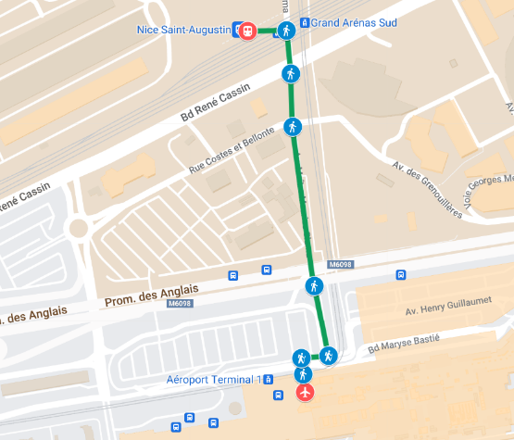  From Terminal 1: Less than 500 meters far, walk across the street and take the dedicated pedestrian walkway under the bridge, which takes 7 minutes. Google Maps maybe doesn’t give the right direction as that is a new train station. | 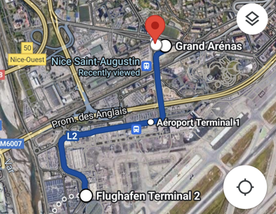 From Terminal 2: With the tram, FREE, no-need to buy a ticket reach Terminal 1 and walk, or might as well stay for another stop till Grand Arenas next to the train station.
NOTE : Nice Saint-Augustin (Airport) is a relatively new train station that moved, it is now located across of the airport Nice Terminal 1, maybe will not appear on your Google Maps and instead guide you to the older location of the train station of Nice Saint-Augustin.
NOTE : When you buy a train ticket in France, you need to stamp it at the machine before you board, otherwise it is not valid and you bought it for nothing. The French word for this “punching” is “compost” and you find the machine at the entrance of the platform.
Further details on the airport website:
https://www.nice.aeroport.fr/en/directions/train
Taxi/Uber options for Nice Airport / Palais des Congres de Juan-les- Pins/Antibes « Antipolis »
Pick-up:
- Terminal 1 - pro. parking
- Terminal 2 - bus station entrances A3 and A4

Road: 20 kilometres 30-35 minutes
- Uber: About 40 EUR
- Taxi: About 70 EUR

From Juan-les-Pins station to Palais des Congres de Juan-les-Pins/Antibes « Antipolis »
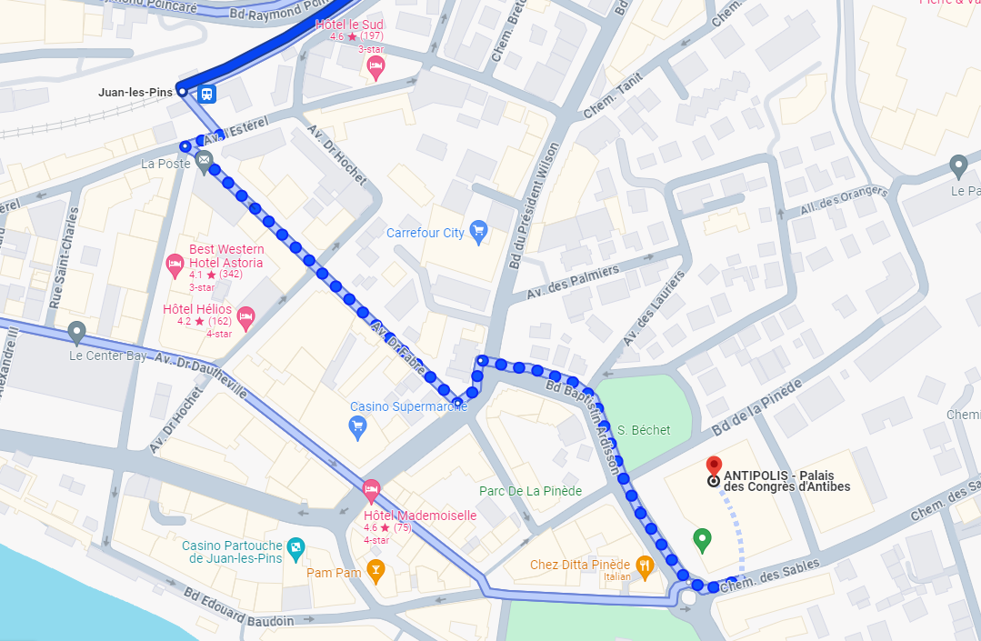

From the Juan-les-Pins train station it takes only 8 minutes walk to the Palais des Congres

